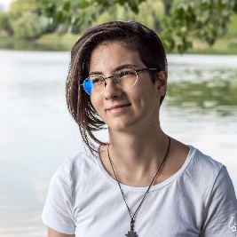

Ișfan Maria-Cătălina

Research assistant in the Cosmology and AstroParticle Physics Group

|  |  |  |
| --- | --- | --- |
| [Welcome](Ișfan%20Maria.htm) | [CV](Curriculum%20vitae.htm) | [Contact](Contact.htm) |

I started my collaboration with ISS by doing simulations of binary systems of inspiraling black holes,

as a part of my practical activities at the Faculty of Physics. However, I wrote my bachelor's thesis

about the properties of the wave function of an electron in a solid material that presents the Hall

effect.

After I got my degree, I joined this group and started studying quantum computing. Our goal

is to develop quantum neural networks that process data from the LISA mission, as a Romanian

contribution to this space mission.

Also, I participated as a volunteer to several scientific popularization events „Researchers’ Night” (2021)

and „Școala de Vară de Știință și Tehnică de la Măgurele” (2021).